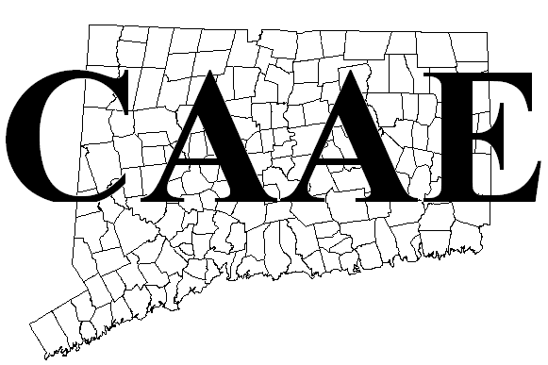
 | Bill To |  | C.A.A.E.  931 North River Road  Coventry, CT 06238 |  | Mail To | Audra Leach, CAAE Treasurer  931 North River Road  Coventry, CT 06238 | School District
 |  |  |  |  |  |  | School Name
 |  |  |  |  |  |  | Date
Qty |  | Item |  | Description |  |  |  |  | Unit Price | Total
 |  | CAAE - Regular |  | Anyone who is professionally qualified to teach agriculture in K-12 or postsecondary public or private schools or state staff |  |  |  |  | 60.00
 |  | CAAE – Substitute |  | Substitute memberships |  |  |  |  | 30.00
 |  | CAAE - Student |  | Undergraduates training for careers related to agricultural education |  |  |  |  | 1.00
 |  | NAAE – Active |  | Anyone who is professionally qualified to teach agriculture in K-12 or postsecondary public or private schools or state staff |  |  |  |  | 60.00
 |  | NAAE – Associate |  | Anyone engaged in agricultural education who are not professionally qualified to teach agriculture |  |  |  |  | 35.00
 |  | NAAE – Student |  | Undergraduates training for careers related to agricultural education |  |  |  |  | 10.00
 |  | Ag Ed Magazine |  | professional journal for agricultural education published under the sponsorship and control of an editing-managing board of professional educators in the field |  |  |  |  | 15.00
Please return the portion below with your payment. |  |  |  |  |  |  |  |  | Subtotal
 |  |  |  |  |  |  |  |  | Balance Due | 60.00

Remittance

Invoice/ PO #
Check #
School District/ Name
Date
Amount Enclosed
Audra Leach,
CAAE Treasurer
931 North River Road
Coventry, CT 06238
Treasurer contact: Audra Leach
Phone 860-483-0018
E-mail audra.leach@gmail.com
Web site http://www.caaeonline.org

