National FFA Update, Summer 2016
For additional information, please contact your LPS specialist.

New CEO for national ffa
Mr. Mark Poeschl started August 1 as the new CEO of National FFA. Mr. Poeschl will attempt to fill the shoes of Dr. Dwight Armstrong who retired after 7 years in that position. Mr. Poeschl has spent his career in animal nutrition with Ralston Purina, Provimi BV and Cargill. He has a passion for FFA and is a past Nebraska FFA member and state officer. For more information, read the press release here.

Agexplorer – find your future in agriculture
AgExplorer is an agricultural career exploration tool that will connect over 629,000 FFA members with rewarding careers in agriculture. Beyond that, it will also serve as an education and advocacy tool to increase public awareness of the many careers available in agriculture.

AgExplorer has four components
- 8 career pathway pages and an Agricultural Education career focus area page
  - Each page includes a video highlighting each pathway and focus area.
- Career profiles of 235 unique careers available in agriculture
  - Profiles provide a description, tasks and responsibilities, average income, education requirements, job outlook and potential employers.
  - Includes link to database of all two and four year colleges and universities that offer a degree in an agricultural field.
  - Link to live jobs specific to each career via AgCareers.com
- Career Finder: an interactive assessment to match students with potential careers
  - Career matches will be saved in FFA.org user profile
  - Teachers will be able to see their students’ results
- 6 virtual field trips of platinum sponsors to be produced over 3 years
  - The first two virtual field trips will occur in September and November 2016.

National FFA and Discovery Education (DE) have joined forces to create a robust, comprehensive career resource to help students and adults explore the broad range of careers within the agricultural industry. AgExplorer is an FFA initiative, but Discovery Education is building and hosting the AgExplorer microsite. AgExplorer will look and feel like an extension of FFA.org and will reinforce our commitment to cultivating the agriculture workforce of tomorrow. DE will leverage current U.S. outreach channels including the Discovery Educator Network, DE social platforms, direct-to-educator e-blasts and newsletters to share AgExplorer with its millions of users.

Our partners at AgCareers.com used their connections in the agricultural industry to identify a list of 235 unique careers in agriculture that was inclusive without duplicating careers. AgCareers.com also developed the content found in the career profiles using job descriptions and information provided by agricultural companies.

Since AgExplorer will serve as an education and advocacy tool to inform the public about careers in agriculture almost all of AgExplorer will be in front of the log-in. It will always be accessible via My Journey on FFA.org, but non-FFA.org users will be able to access the site through Discovery Education. The assessment tool on AgExplorer, Career Finder, is only available to FFA.org users. AgExplorer will be launched and available in My Journey in June.

National FFA Convention and Expo news
In just a few short months, the National FFA Convention and Expo will take place in Indianapolis, Indiana. The dates for this year’s convention are October 19-22. The dates for 2017 and 2018 have been set and available online but the dates of the 2019-2024 conventions, also in Indianapolis, are still in negotiations. The website is live, ffa.org/convention, and chapter housing is open. Remember that Indiana does not offer tax exemption for schools.

National Convention – What’s New?

- Single concert night on Wednesday – Cole Swindell and Chris Young with the Henningsens
- “Teachers Teaching Teachers” workshops in the Teachers’ Professional Development Classrooms.
- National Chapter Award dinner Thursday night.
- New Convention and Expo Credentials – RFID chip embedded in name badges

New Convention & Expo Credentials
- Each attendee will receive a name badge with a radio frequency identifier (RFID) embedded in the badge
- This will let us better understand attendee/delegate interests and preferences in order to maximize your convention experience.
- The information collected will be used to improve future events.
- With this new system in place you can now increase or decrease registration items prior to the deadline
- You can also return to your original registration without starting over
- At the end of your registration, look for this type of message
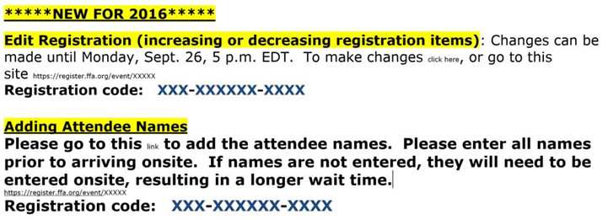

How will tickets be delivered?
These events still use paper tickets and will be mailed in advance or handed out by program staff:
- Concert
- Rodeo
- Parking and Shuttle Passes
- Contestant Banquet Tickets (sent from program staff as in the past or picked up at team orientation)

These events will have tickets loaded on RFID chip:
- Session 1 A, B, C
- Days of Service
- Career Success Tours
- Hypnotist shows
- Additional Banquet Tickets ordered online (for additional tickets purchased beyond those listed above)

How do I receive my registration materials?
- Paper tickets will be mailed after September 26 registration closes
- For registration where names have been entered online prior to October 10: Bring Registration Email and pick up name badges onsite
- For registration where names have NOT been entered online prior to October 10: Go to onsite kiosk and enter all names; name badges will be printed onsite

Important Convention Related Dates:
- August 17 - Registration opens 1:00 PM EDT
- September 26, 5:00 PM EDT – Online Registration closes and last day to edit registration numbers
- October 10 – Deadline to add names to registration online; after this date names will have to be added onsite

BE WATCHING THE CONVENTION WEBSITE IN AUGUST FOR A “HOW TO GUIDE” TO ASSIST YOU WITH THIS PROCESS!

New SAE Videos available!
Check out the new SAE videos. These are excellent tools to help promote SAEs to your students, parents, administrators and Alumni members. Found on the Educator Resources page under the Classroom Videos link. While you are there, check out all the other great videos available for teachers.

2017-2021 revisions
CDE Revisions
- Leadership events are now LDEs
- More focused alignment with AFNR standards
- There are changes to every CDE/LDE except Creed so be sure to check out CDE Handbook
- Changes to Marketing Plan and Ag Sales – only rubrics were changed
- All FFA members grades 7-12 will be eligible to participate in all events except Conduct of Chapter Meetings and Creed
- CCM full event in 2017
- No more “low score dropped”; teams of four in all team CDEs except Meats
- Many Floriculture changes
- No more traditional minutes in Parli-Pro and all teams will do Team Problem Solving
- Employment Skills LDE (FKA Job Interview) will include a pre-convention online application
- Ag Tech Mech has gone from 331 competencies down to 139 competencies
- Extemporaneous Public Speaking now has 6 topic areas and will include an 18 topic draw
- Farm and Agribusiness Management (name change) includes an HR segment
- ALL CHANGES TAKE EFFECT FALL 2017!!!!
- Send questions at any time to cde@ffa.org

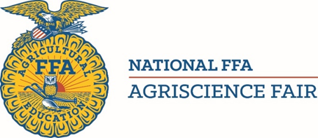
Agriscience Fair
- Six divisions with different grade breakdown
  - Grades 7-8 – Individual and Team of Two
  - Grades 9-10 – Individual and Team of Two
  - Grades 11-12 – Individual and Team of Two
- Different pre-qualifying scoresheets and rubrics for Grades 7-8
- State staff must sign – do not mail straight to Indianapolis
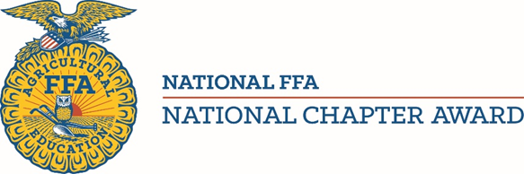
National Chapter Award
- New Divisions
  - Growing Leaders
  - Building Communities
  - Strengthening Agriculture
- Form I requires a minimum score to advance
- Form I based on National Quality Chapter Standards and National Quality Program Standards
- Model of Innovation changed to Premier Chapter
- Entire application online in the Application Center in My FFA

Please refer to the CDE, Agriscience Fair and National Chapter Award Handbooks for all changes!

alumni news
Regional Development Conferences
The National FFA Alumni Association is bringing professional, personal and FFA alumni development to the masses. Regional Development Conferences are designed to engage individual members, local FFA alumni leaders, state FFA alumni leaders, agricultural educators and others involved with agricultural education. Attend the one that best fits your location and calendar. Check out the Alumni website to locate the one nearest you.

Other Alumni News
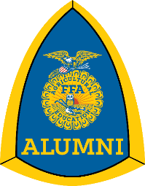
- All identified 12th-16th grade students are automatically being advanced to Alumni each April
  - Save Advisor time and take work off your plate
  - Please make sure grade level is included for each student
- Have your Alumni leader enter Impact Data on their affiliate profile
  - Record number of volunteers, volunteer hours, amount of money raised
- National FFA Convention and Expo
  - Friday = Alumni Day convention wide
  - All alumni activities will be held of Friday
  - 1 Alumni General Session
  - Larger Alumni Reception
- ADC staying in Kansas City every summer
- Reduced registration cost
- 2-day conference with optional 3rd day for tours
- Beginning in 2017 alumni chapters/associations will be asked to bring FFA officers with them to so that they can develop an Advocacy Plan to use back home during the following school year.

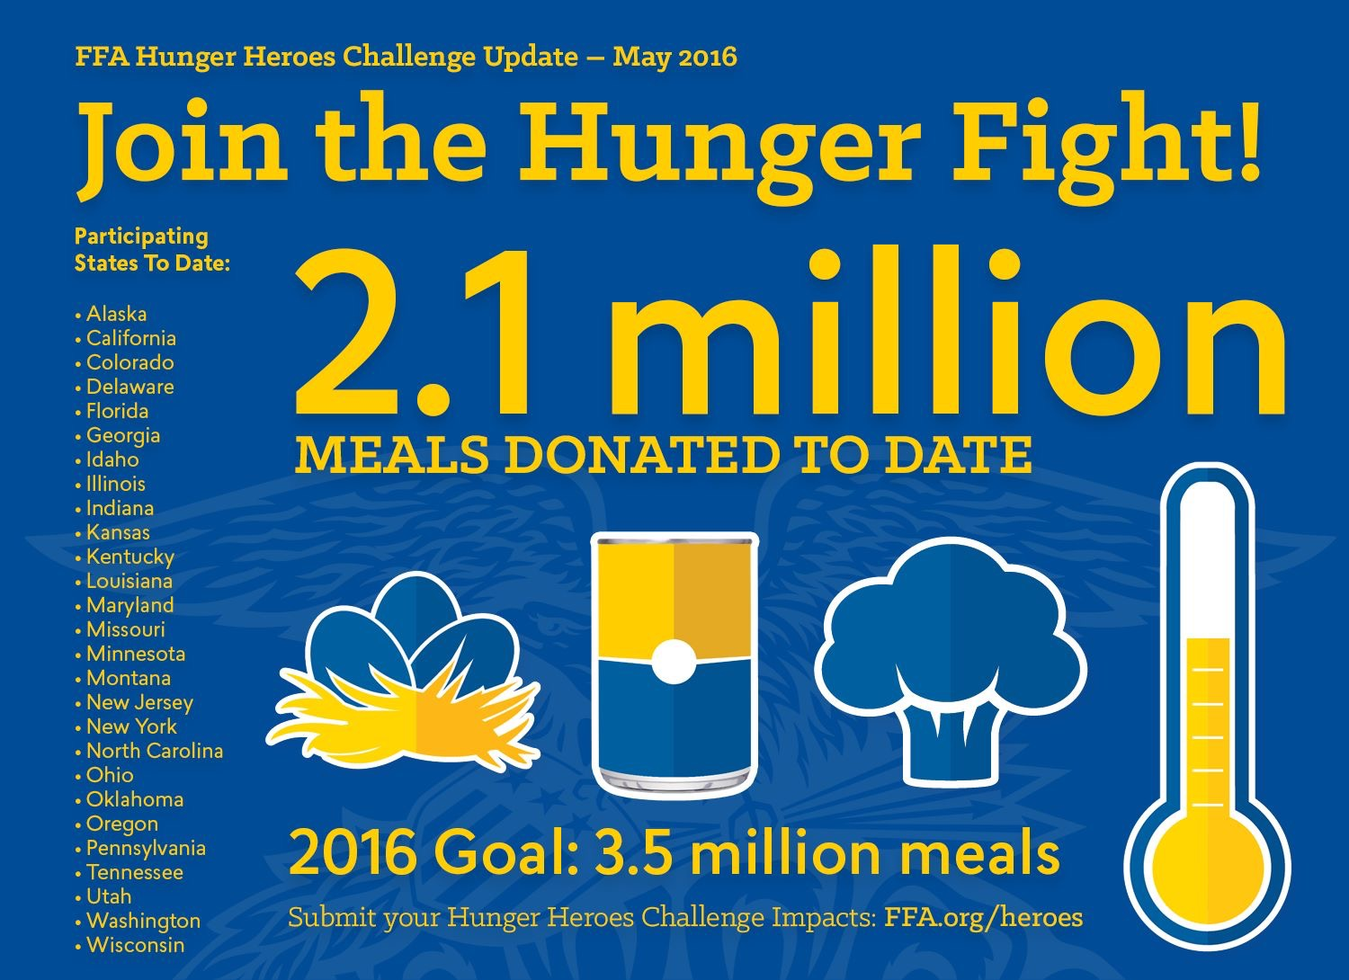
Living to serve – hunger heroes challenge
Help your state win a truckload of protein from Tyson while qualifying for monthly drawings for your chapter. Chapters that log activities qualify when reporting activities from last school year through September 30th. The state with the highest percentage of chapter participation will win the truckload of protein. Log your hunger relief related efforts at www.ffa.org/heroes.

My ffa profile project
Coming this fall, a new improved chapter profile. With the rewrite of the new chapter profiles, we will be able to collect critical data to tell our story and show our impact at the chapter, state and national levels. The advantages of the new My FFA Profile are many:
- Improve Single Sign On capabilities – makes it easier for you to sign in to all the different systems in FFA.
- Merge multiple databases; data updated in one system will automatically be updated in other systems!
- More forms and applications will be auto-loaded from profile information
- Capability to upload documents to the website such as Program of Activities, Charter,
- Provide historical details on your chapter

With the change in the profile come changes for required fields.
Student Roster:
- Date of Birth and Grade will be required

Advisor Profile required fields:
- Contact Information – email, cell phone, work, phone, etc.
- Professional Demographics – years teaching, degree earned, first year teaching ag, etc.

Chapter Support Programs
Scholarships
- 116 sponsors awarded 1,791 individual scholarships worth over $2.6M
- 8.383 students applied, (up 1,212)
- 1 out of 4.7 applicants received $$
- The average grade point for recipients was 3.75 on a 4.0 scale; Average ACT score 21.26; Average class rank 21/152
- 261 Valedictorians
- Financial need is considered for many.
- Scholarships can be for either two-year or four-year degrees or vocational programs and range in size from a $300 endowment to full tuition for four years.
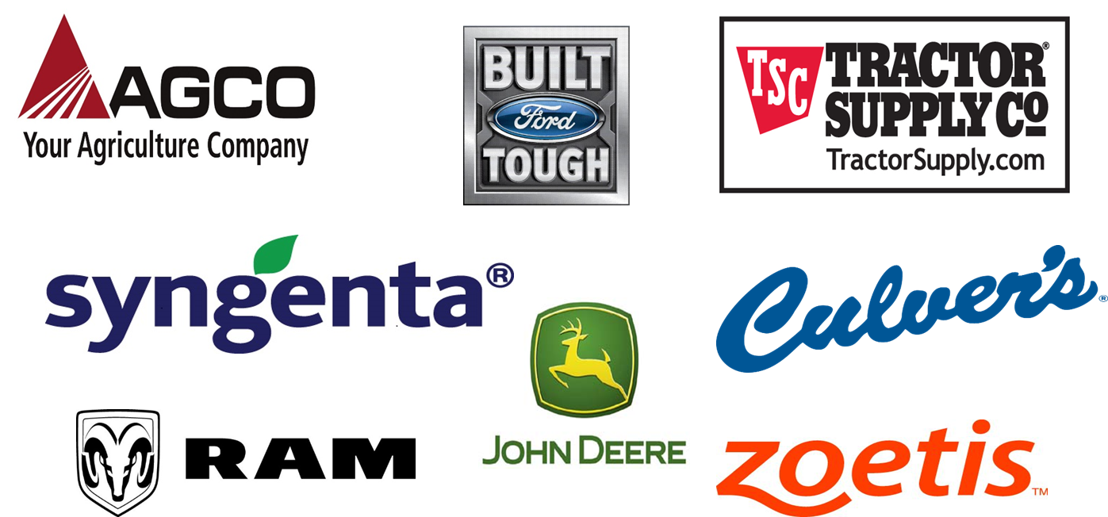
- Scholastic record is important, but not always the determining factor.
- College students eligible to apply while in college

Give the Gift of Blue
- Free FFA Jacket with tie or scarf (shipping included)
- Simple application with one essay question
- Must be approved by advisor to receive jacket
- Not a competitive program

Local Engagement Programs
Check out all the ways sponsors want to engage with your local chapter to provide money to your students. Many of these programs are offered different times of the year so check back often. You can find the complete list and instructions on how to engage with sponsors at https://www.ffa.org/localengagement.

