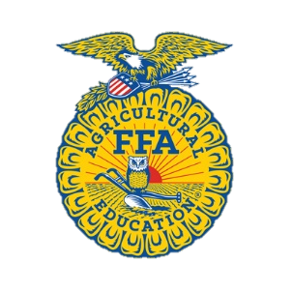
Superintendents: To Be determined
Event held at State FFA Convention. Recognition of the team will be held on stage.

Rules and Regulations
. Each chapter is entitled to one (3) member team and two (2) alternates. Only Freshman FFA members are eligible to compete.
- The contestant cannot be in the state FFA Creed Leadership Development Event, Opening
Ceremonies Event.
- All participants must be in official FFA dress.
- Teams will draw numbers for position.
- Depending on the number of teams, there may be a first-round bye.
- All questions will be related to only the FFA and the current Official FFA Manual will be the only reference used.
- There will be a total of 18 questions (9 per team). At that time, a winner will be determined. If there is a tie, 3 more questions will be asked per team.
- The questions will alternate from one team to another.
- The first question is directed to team A, member #1 (within 15 seconds, 2 pts. if correct), if incorrect, members of team A together may try for I point (15 seconds).
10 . If the question is still not answered correctly, team B (as a team) can try for I point (15 seconds).
11. Only when the individual cannot answer correctly. can the team consult.
If there are more than 8 teams, there will be one or more teams getting a 1st round bye. Each round should take a maximum of 18 minutes (Probably much less)
There will be at least one timekeeper.
A moderator will ask questions.
A side panel of two or more judges will verify all answers as well as score.
Each team is allowed one repeat question/round and one repeat question/tie-breaking session
Rev. 2/7/17

